第二次作业

代码运行结果

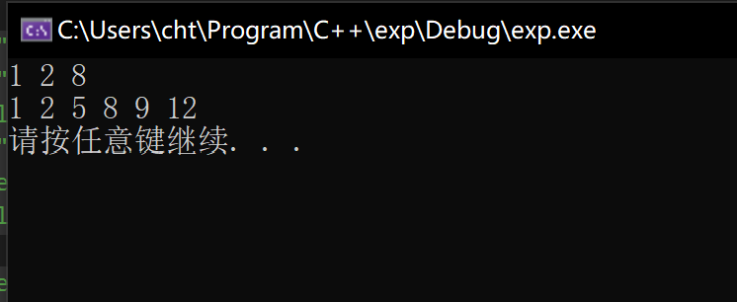

总结

合并两个列表使用了归并排序算法。

排序一个列表原来打算使用插入排序实现，但是因为做不出来，就直接创建新的节点来实现。

代码

[//minilist.h](vscode-resource://minilist.h/)

#pragma once

#include<exception>

#include<initializer_list>

#include<iostream>

#include<algorithm>

using namespace std;

template <typename T>

class node {

public:

node(T value, node<T>* next = NULL) {

this->value = value;

this->next = next;

}

T value;

node<T>* next;

};

template <typename T>

bool myComparer(node<T>** first, node<T>** second) {

return (&second)->value > (&first)->value;

}

template <typename T>

bool myComparerDesc(node<T>** first, node<T>** second) {

return (&second)->value < (&first)->value;

}

template <typename T>

class minilist {

public:

minilist() {

first = NULL;

last = NULL;

}

minilist(initializer_list<T> l)

{

for (auto p = l.begin(); p < l.end(); p++) {

append(*p);

}

}

~minilist() {

clear();

}

minilist(const minilist<T>& other) {

node<T>* c = other.first;

while (c != NULL) {

append(c->value);

c = c->next;

}

}

minilist<T>* clone() {

minilist<T>* other = new minilist<T>();

node<T>* c = first;

while (c != NULL) {

other->append(c->value);

c = c->next;

}

return other;

}

void append(T value) {

node<T>* c = new node<T>(value);

if (empty()) {

first = c;

last = c;

}

else {

last->next = c;

last = c;

}

}

T at(int index) {

node<T>* c = nodeAt(index);

return c->value;

}

*//插在第index个节点的后面，若index<0，插在头部。*

bool insertAt(T value, int index) {

node<T>* c = new node<T>(value);

if (index < 0) {

c->next = this->first;

this->first = c;

}

else if (index >= length()) {

return false;

}

else {

node<T>* p1 = nodeAt(index);

c->next = p1->next;

p1->next = c;

}

return true;

}

*//删除在index处的节点*

bool removeAt(int index) {

if (empty()) {

return false;

}

else {

if (index == 0) {

node<T>* c = first;

first = first->next;

delete c;

if (first == NULL) {

last = NULL;

}

} else {

int length = length();

if (index >= length) {

return false;

} else {

node<T>* p1 = nodeAt(index - 1);

node<T>* p2 = p1->next;

p1->next = p2->next;

delete p2;

}

}

}

return true;

}

size_t length() {

size_t _length = 0;

node<T>* c = first;

while (c != NULL) {

_length += 1;

c = c->next;

}

return _length;

}

bool empty() {

return first == NULL;

}

node<T>* firstNode() {

return first;

}

friend ostream& operator << (ostream& streamout, minilist<T>& list) {

node<int>* current = list.first;

while (current != NULL) {

streamout << current->value << " ";

current = current->next;

}

return streamout;

}

void clear() {

node<T>* c = first;

while (c != NULL) {

node<T>* next = c->next;

delete(c);

c = next;

}

}

void mySort(int direction = -1) {

int _length = length();

T* arr = new T[_length];

node<T>* c = first;

int i = 0;

while (c != NULL) {

node<T>* t = c;

arr[i++] = c->value;

c = c->next;

delete t;

}

sort(arr, arr + _length);

first = NULL;

last = NULL;

for (int i = 0; i < _length; i++)

{

append(arr[i]);

}

}

void join(minilist<T>& other) {

node<T>* c = other.first;

while (c != NULL) {

append(c);

c = c->next;

}

}

void join_sort(minilist<T>& other, int direction=-1) {

minilist<T>* cloned = other.clone();

node<T>* p1 = cloned->first;

while (p1 != NULL) {

node<T>* p2 = first;

node<T>* p3 = NULL;

if (direction < 0)

{

while (p2 != NULL && p1->value > p2->value)

{

p3 = p2;

p2 = p2->next;

}

p3->next = p1;

node<T>* t = p1;

p1 = p1->next;

t->next = p2;

}

}

cloned->first = NULL;

delete cloned;

}

*//置换list的元素，用到了5个工作指针*

void reserve() {

int _length = length();

if (_length >= 1) {

node<T>* p1 = first;

node<T>* p2 = p1->next;

first->next = NULL;

last = first;

while (p2 != NULL && p2->next != NULL) {

node<T>* tp1 = p2->next;

p2->next = p1;

p1 = p2;

p2 = tp1;

}

p2->next = p1;

first = p2;

}

}

private:

node<T>* first = NULL;

node<T>* last = NULL;

node<T>* nodeAt(int index) {

node<T>* c = this->first;

int i = 0;

while (i <= index) {

if (c == NULL) {

throw exception("invalid index");

}

else if (i == index) {

return c;

}

else {

c = c->next;

++i;

}

}

}

};

[//main.cpp](vscode-resource://main.cpp/)

#include<iostream>

#include"minilist.h"

using namespace std;

int main()

{

minilist<int> list1 = { 1,8,2 };

minilist<int> list2 = { 5,9,12 };

list1.mySort();

cout << list1 << endl;

list1.join_sort(list2);

cout << list1 << endl;

system("pause");

}